IDENTITY CARD FOR POLITICAL PARTY
ELECTION REPRESENTATIVES/COUNTING REPRESENTATIVES
POLLING OFFICIALS/ELECTION OFFICIALS

1. Political Party 2. Election Representative

…… Dzongkhag
Name………………… …………
VPIC No.: ……………………..

CANDIDATE
Issuing Authority
OFFICE OF THE
RETURNING OFFICER

NA-GE ELECTION
………..(Year)
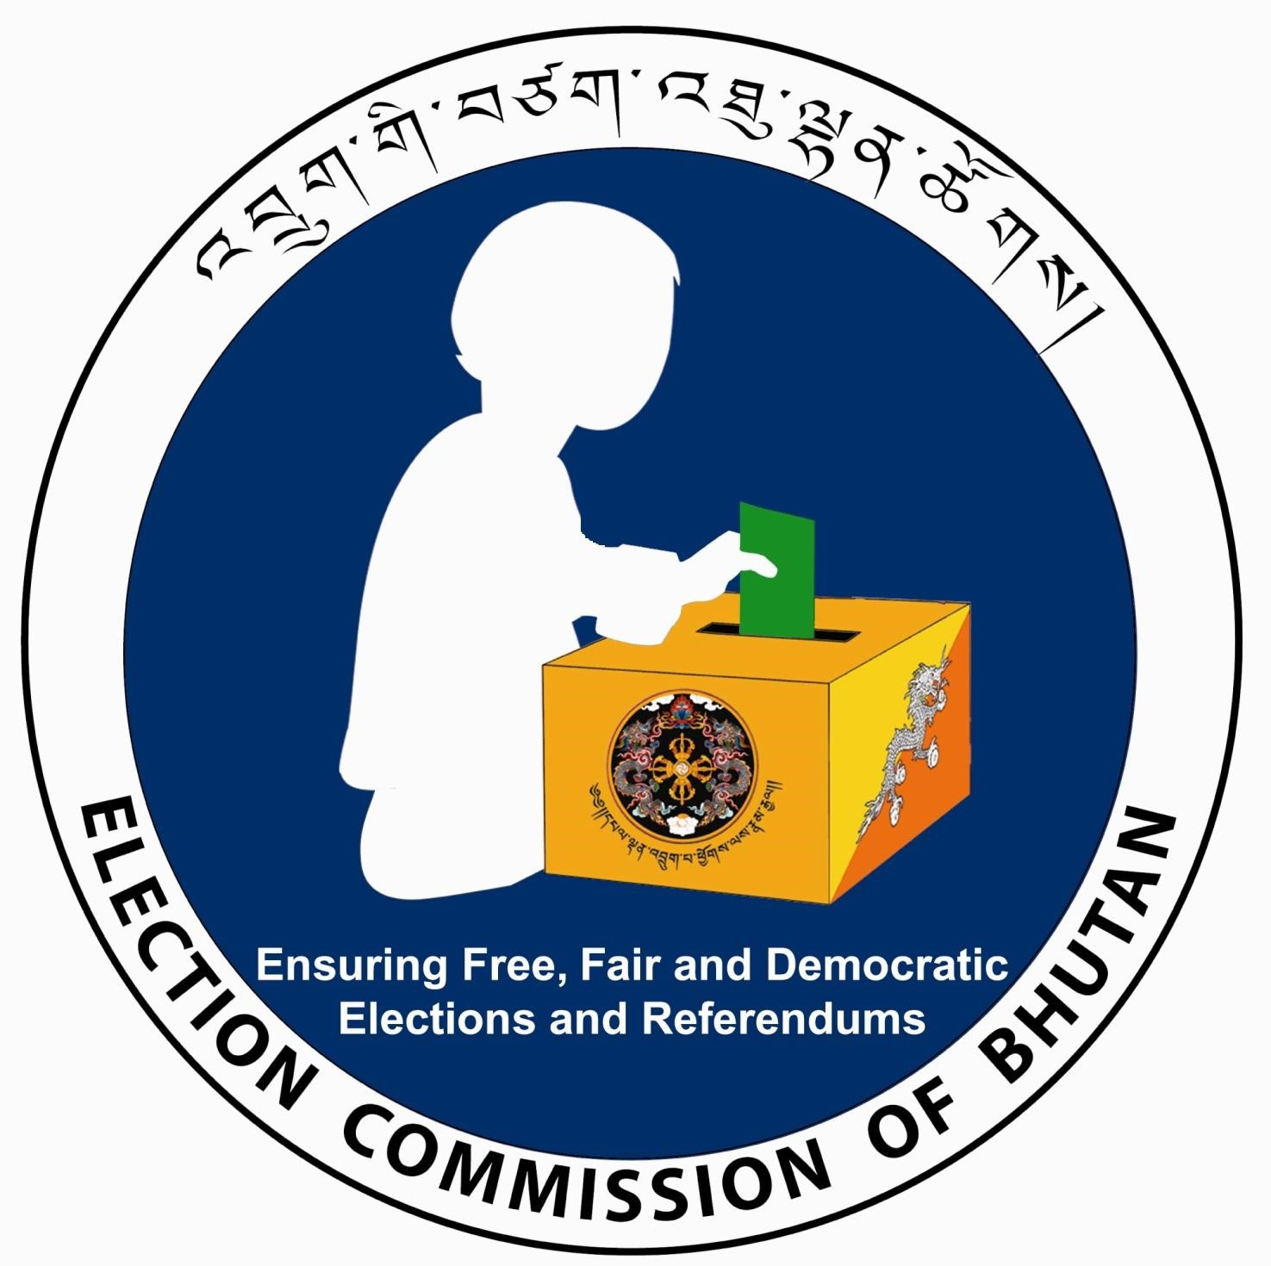

…… Dzongkhag
Name………………………..…
VPIC No.: ……………………..

Election
Issuing Authority Representative
OFFICE OF THE
RETURNING OFFICER

NA-GE ELECTION
………..(Year)

…… Dzongkhag
Name…………………………
VPIC No.: ……………………..
Polling Station………………

Counting
Issuing Authority Polling Representative
OFFICE OF THE
RETURNING OFFICER

NA-GE ELECTION
………..(Year)

Presiding Officer
Polling Officer I/I/II
Lady Security

Issuing Authority
OFFICE OF THE
RETURNING OFFICER

NA-GE ELECTION
………..(Year)

- Counting/Polling Representative 4. Polling Official

3. Polling Officials

