IDENTITY CARD FOR CANDIDATES
ELECTION REPRESENTATIVES/COUNTING REPRESENTATIVES
POLLING OFFICIALS/ELECTION OFFICIALS

1. Candidates 2. Election Representative

…… Dzongkhag
Name:………………… …………
VPIC No.: ……………………..

CANDIDATE
Issuing Authority
OFFICE OF THE
RETURNING OFFICER

NC ELECTION
………..(Year)
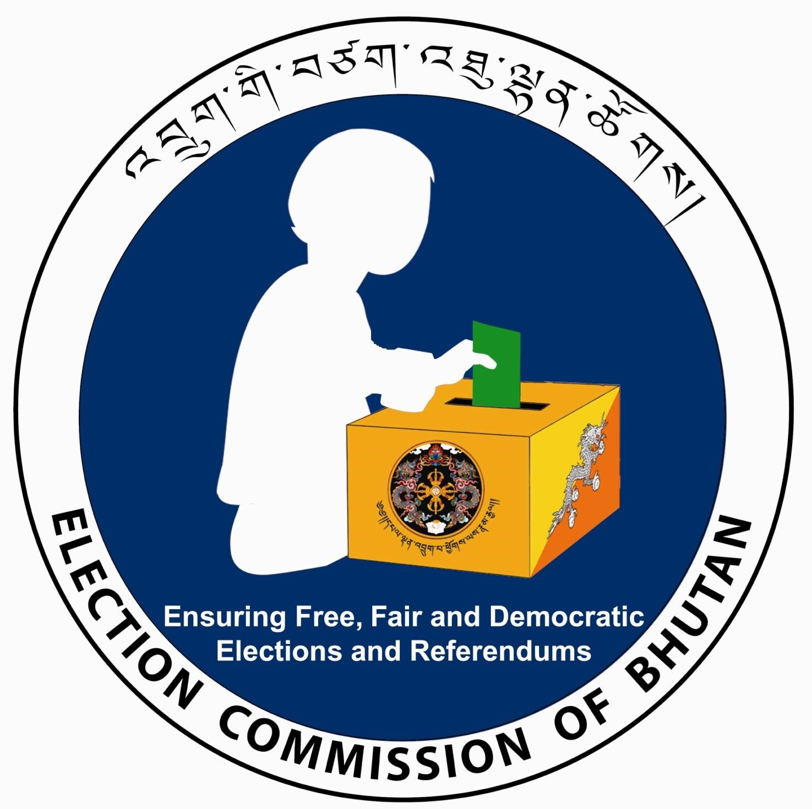

…… Dzongkhag
Name:………………… …………
VPIC No.: ……………………..

Election
Issuing Authority Representative
OFFICE OF THE
RETURNING OFFICER

NC ELECTION
………..(Year)

…… Dzongkhag
Name:………………… …………
VPIC No.: ……………………..
Polling Station:……………….

Counting
Issuing Authority Polling Representative
OFFICE OF THE
RETURNING OFFICER

NC ELECTION
………..(Year)

Presiding Officer
Polling Officer I/I/II
Lady Security

Issuing Authority
OFFICE OF THE
RETURNING OFFICER

NC ELECTION
………..(Year)

- Counting/Polling Representative 4. Polling Official

3. Counting/Polling Representative 4. Polling Officials

